**Meeting for Westmarch BoD August 20, 2025, 6:30pm PST**

Join Zoom Meeting

[**https://us06web.zoom.us/meetings/83645173348/invitations?signature=O_-u62pYKfr7LgjQRBJHxtBuPPXPKzagN04sx-CGpV0**](https://us06web.zoom.us/meetings/83645173348/invitations?signature=O_-u62pYKfr7LgjQRBJHxtBuPPXPKzagN04sx-CGpV0)

1. **Meeting call to order**
2. **Attendance Call**
3. **Officer Members in attendance**: Royce Griffiths, Karl Craig, Ethan Copitch, Ginger Conrad, Christine Stender, Leon Starks
4. **Guests in attendance:** Ben Smith, Frankie DiMento, Brian Ouellette, Jack Kiernan

Start recording.

**Agenda**

1. **Reading of Minutes of Last meeting**
2. **Monarch Providing Credit for Attendance?** 
   * Yes
3. **Welcome new BOD member and assign position**
   * Confirm and welcome the New BOD member to the BOD.
   * Currently have opening in the Secretary Position

general consent vote: 5 Yes, 0 No, 0 abstain, 1 not present.

1. **Welcome new KPM** 
   * Welcome the recently elected Kingdom PM member to the BOD.
   * Yay!
2. **Director and officer insurance.** 
   * Althing Passed. Liaison to liaise with insurance to get it ordered.
     1. Liaison to liaise!
     2. KPM to pay! (from Westmarch general account)
        1. Up to $2572
3. **Reminders from Last meeting – Reminders (Ethan)**
   * **How many years we want to average for budgeting purposes on events.**
     1. 3 years - update the BOD handbook **(Ethan)**
   * **CEO/CFO change to corpora draft Althing Item**
     1. Or update Statement of information from Secretary of State (CA) every monarchy election. **(Ethan)**
     2. Pushed to October Althing.
   * **Contract updates Ethereal Hollow, Stoneheart, Anduril**
     1. Both lands returned paperwork.
     2. Brian has gotten Adobe/Docusign to agree to 501c3 status.
     3. We now have Doucsign, BOD can finally sign these.
        1. Check your email!
   * **California Tax Exempt status (Ethan)**
     1. It has been completed and set to the state. Pending determination.
        1. No change
4. **Firework Fundraising idea (Ginger)**
   * Phantom fireworks as a 501c3 we could sell fireworks, would need to apply back in February.
   * Additional Information <https://drive.google.com/file/d/1tC21Du__DkkuB4iBZzwHBdRgSDZ6a5xf/view>
   * Liaison to liaise with firework company, ask about minimum selling times**.**
     1. Must support a full week**.** Do not need to sell every day; however, the both must be manned 24/7 as the fireworks are a fire hazard.
5. **Seller’s permit for the kingdom and how to get it (Athena/Royce)**
   * Any update?
     1. Royce still working on NAICS code to use for a LARP.
6. **Walk on items**
   * Milan (or other) to make pamphlet to present to other business about donating to our 501c3.
   * Kingdom to Audit lands per Corpora 9.2.4
   * Dragonvale to start forming a BOD.
7. **SCHEDULE:**

* September 17th @6:30pm

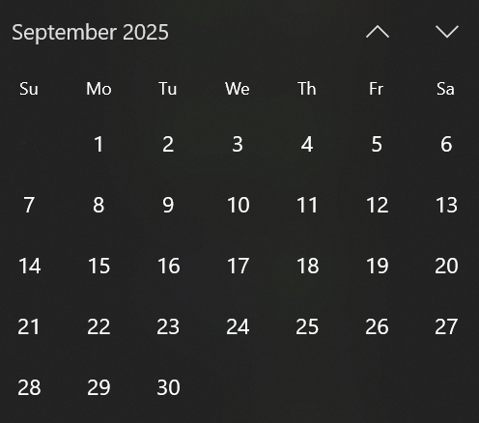

1. **Adjournment-** stop recording.