**Meeting for Westmarch BoD May 22, 2025, 630pm PST**

**Zoom Meeting**

[**https://us06web.zoom.us/j/85227880704?pwd=5VpsUWdhrXkAEjrLxYtF1yEWrbhBQg.1**](https://us06web.zoom.us/j/85227880704?pwd=5VpsUWdhrXkAEjrLxYtF1yEWrbhBQg.1)

**Meeting ID: 852 2788 0704**

**Passcode: 702564**

1. **Meeting call to order**
2. **Attendance Call**
3. **Officer Members in attendance**: Royce Griffiths, Ethan Copitch, Leon Starks, Karl Craig, Athena Velasco
4. **Guests in attendance:** Frankie Dimento, Jason Katzner, Brain Ouellette, Allicia Barnett, Morgan Cook, Alexis Dispoto, Darcy Gardner

Start recording.

**Agenda**

1. **Reading of Minutes of Last meeting**
2. **Welcome the new Monarch!**

Royce Griffiths

1. **Monarch Providing Credit for Attendance?** 
   * **YES**
2. **Determine treasure position**
   * Alternate steps up to BOD.
   * 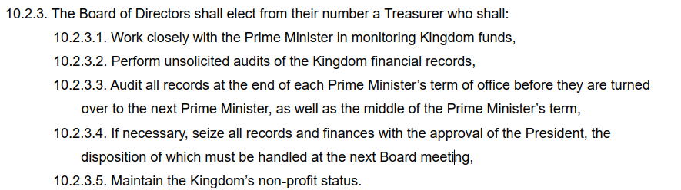BOD determines officer positions

Roll call vote – Athena to Treasure  
Yes: 5 No: 0 Abstain: 0 Not Present: 2

1. **Reminders from Last meeting – Reminders (Ethan)**
   * **Director and officer insurance.** 
     1. Feedback from April Althing passed asking us to look into it
     2. Need quote, and then put on future Althing **(Ethan)**
   * **How many years we want to average for budgeting purposes on events.**
     1. 3 years Will need to update the BOD handbook **(Ethan)**
   * **CEO/CFO change to corpora draft Althing Item**
     1. Or update Statement of information from Secretary of State (CA) every monarchy election. **(Ethan)**
   * **Contract updates Ethereal Hollow and Stoneheart**
     1. Both lands returned paperwork. Waiting on BOD to sign **(Ethan/Brian)**
2. **Anduril needs Land contract - Discussion (Ethan)**
   * Welcome new land!
   * Get the land a contract
   * Need to get a better way to sign documents **(Ethan/Brian)**
     1. Concern that the Land contract does not explicitly allow the land to license/use the Amtgard IP.
3. **California Tax Exempt status – Discussion (Ethan)**
   * FTB 3500A form is the California Tax Exemption.
   * It has been completed and set to the state. Pending determination.
     1. Has been received by state of California
     2. Will be processed in the order it was received.
4. **Event Emergency Plan – (Milan/Royce)**
   * See attached emergency plan template as part of discussion
5. **BOD reach out to King City City Council to inquire about King City site and its problems**
   * Note: The San Lorenzo park is run by the county of Monterey.
     1. Site not currently being used for FoG 2025
     2. But we might return to the site in the future
        1. Ask the liaison to contact the King City
           1. Mention we are leaving the site because the county is no longer meeting our requirements.
        2. Send as official letter
     3. See if we can get draft by next BOD meeting.
6. **Who is authorized to give a donation receipt on behalf of Westmarch - (Royce)**
   * We have 4 books of donation receipt forms. Who should be authorized to use them?
     1. BOD are the only authorized members able to provide donation receipts. Corpora 10.1.1.1 says the BOD deals with outside organization and contractual obligations. Donations receipts are business documents and fall under the purview of the BOD.
7. **Merch sales - (Royce)**
   * Want to sell Shirt, water bottles, patches, stuff, etc.
   * Branded items for Westmarch, events, land
   * Sell art items for Trailer.
     1. Example: Art contest, everyone submits a design example of how they plan to paint the trailer. The populace votes via donation, whichever design gets the most donated wins
     2. Check the OAG guide for fundraising to ensure we are in compliance.
8. **Sellers Permit – (Royce)**
   * Might be in Westmarch’s interest to get a seller’s permit (Athena)
     1. Must start tracking sales.
     2. Meals are items sold on site, they must be tracked and taxed.
   * Who is responsible for paying sales tax? Us as the seller or if using a website “marketplace facilitator”
     1. If someone wants to set up a booth they are the seller and responsible for taxes and what not.
     2. Cost is $0 to set up with California department of tax and fees administration.
        1. Must track taxes
        2. At an event: State, and City taxes for the location of the event. Easy to look up <https://maps.cdtfa.ca.gov/>
        3. Online sales is a bit harder.
     3. Must list responsible parties
        1. Must update every time these parties change.
   * Look into have our vets help us out with their veteran benefits?
     1. Vets are exempt from sales taxes for certain items. Typically, only veteran related items.

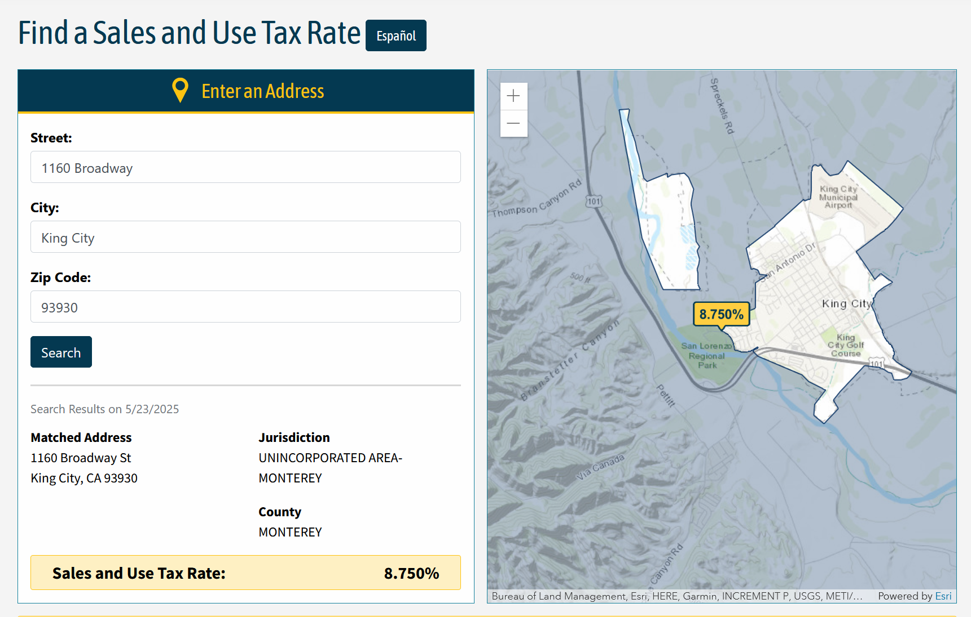

1. **WM getting its square account – (Leon)**
   * Would allow us to take credit card orders at events
     1. Has a 2.6% + 0.15 cents fee when withdrawing from Square.
     2. May be more expensive than CAAmtgard/Paypal
     3. Square is really easy to work with for sales tax.
        1. Used at Darkshore 2023

**Walk on Items**

* Update statement of information with Secretary of State for the new CEO. **(Royce)**
* Next time review Darkshore 2025 post event forms.
* Corpora vs Bylaws. Most kingdoms separate corpora (game rules) vs Bylaws (business rules)

1. **SCHEDULE:**

June 11th, 2025. At 6:30pm.

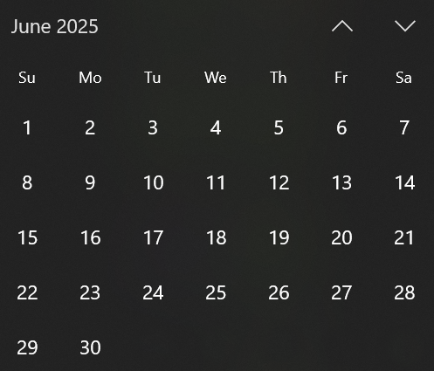

1. **Adjournment-** stop recording.