**Meeting for Westmarch BoD January 15th 2025, 630pm PST**

1. **Meeting call to order**
2. **Attendance Call**
3. **Officer Members in attendance:**
4. **Guests in attendance: Ben Smith, Brian Ouellette**
5. **Reading of Minutes of Last meeting**

**January Agenda**

1. **Congratulations everyone! Elect officers to their new positions**
   * **President – Ethan Copitch**
   * **Vice President – Karl Craig**
   * **Treasurer – Theos (****Royce Griffiths)**
   * **Secretary – Bear Bear (****Kris Sapolu)**
   * **Liaison – Ginger Conrad**
2. **FOG final document review – tabled for January. need to add FOG inventory to the CA Amtgard Inventory List. Low turnout affected event. Sell belt favors at Dungeon with proceeds to go to FOG. REVIST in January.** 
   * **Regent responsible for inventory list.**
   * **Still pending final accounting information from FOG 2024 autocrat**
   * **7.7.3. A complete accounting of income and expenses (with all receipts) from the event must be provided to the Westmarch Prime Minister within 45 days of the end of the event.**

* **Proposal give Autocrat until week before (February 12th), February BOD meeting**
  + **Aye/Nay/Abstain – 7/0/0**
* **Kris Sapolu is willing to allow sale of Belt favors at Dungeon**

1. Director and officer insurance!! Discussion (Talon) would it cover WM in other kingdoms? (can we get umbrella insurance) I need number of participants over and under 18. How much liability? 1mil to 5mil – We need to contact the org and get details. Phone conversation. We’ll make Ben do it and Ethan will help. Table until January.
   * **Talon needs**
     1. **Allowed cost, amount of coverage**
     2. **Recommend using Francis L Dean**
     3. **Will send contact information to new Liason (Ginger Conrad)**
   * **Reach out to Westmarch to get feedback ahead of March althing.**
2. Should Westmarch have an emergency management plan (milan volunteers ) we already have everything else. But this too? Do we need this? Is this a “why not” situation? Unnecessary unless we just make a summarize document. (majority says not necessary).
   * Milan plans to make one because it’s a good idea
   * As part of discussion with 501c3 it would be a beneficial item to have as part of the IRS paperwork.
   * Follow up in February.
3. Incident Form: any forward movement? We have a PDF form and a digital submission form. Yay we did the thing. (contact jotform and make it so it can’t be edited on the back end). Tabled for January.
   * This was fixed <https://www.jotform.com/form/243524158332150>
   * Additional issues have been uncovered. Will continue to work on with Monarchy and IT team.
4. Tabled for December Food safety requirements: Let’s table this and talk about potentially having this for events. Maybe just the Feast Steward – Let’s not set the precedent for the sales of things as it’s not a priority. Then there has been concern to have food safety. People serving without gloves. Tabled for January. Not a requirement. But this should be covered. Lets get a quote. Food handler seems reasonable.
   * Will see if we can get a best practices list that we can follow
   * Does not appear we need to have the full certification at this time.
   * **Motion to close item**
     1. **Aye/Nay/Abstain – 7/0/0**
5. WM event audit form: Records and reviews – then the opinion of the board saying what they did right and wrong. It’s a wording or titling thing. Table for January.
   * See Westmarch Post Event
     1. Recommended to add oversight for Maintenance and Returning of Westmarch equipment and assets.
   * Recommend adding to a future Althing item to get it into the Corpora
   * Table to February meeting to re-review updated form.
6. 501c3 – there is an update!
   * Brian Ouellette, Royce
     1. Recommend that **Brian Ouellette** to special liaison to the IRS.

Motion Aye/Nay/Abstain – 7/0/0

* + We need to update the AMTGARD, KINGDOM OF WESTMARCH, INC (3476405) to move the address/agent off of Brian Ouellette.
  + **Follow up next month.**

Walk on Items

* 2025 Budget
* 2024 Taxes
  + Need to be filed in February
  + Make sure you fill out the statement of information otherwise the BOD can become individually liable.
* Have follow on meeting.

1. **SCHEDULE:**

**Proposal Set next meeting for February 20th @ 6:30pm**

* + **Aye/Nay/Abstain – 7/0/0**

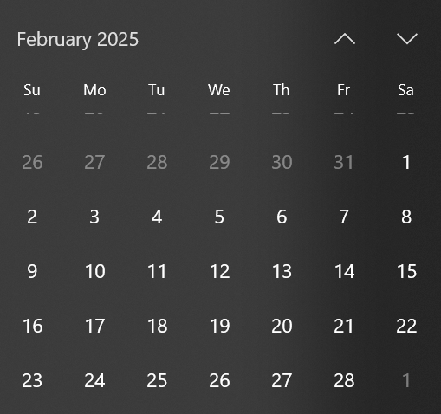

1. **Adjournment-** stop recording.