**Meeting for Westmarch BoD April 16th 2025, 630pm PST**

**Zoom Invite** <https://us06web.zoom.us/j/84024894343?pwd=uWlgaTf0lPLPnS8ATVpFc3lUPqjeFj.1>  
Meeting ID: 840 2489 4343  
Passcode: 649047

1. **Meeting call to order**
2. **Attendance Call**
3. **Officer Members in attendance**: Jackson Wilson-James, Royce Griffiths, Athena, Karl Craig, Leon Starks, Ethan Copitch,
4. **Guests in attendance:** Brain Ouellette, Darcy Gardener, Chaim Weinberg, Jack Keirnan

Start recording.

**Agenda**

1. **Reading of Minutes of Last meeting**
2. **Monarch Providing Credit for Attendance?** 
   * **Yes!**
3. **Director and officer insurance. – Review**
   * Feedback from April Althing
     1. Althing passed
   * Working with a company for D&O insurance
     1. Need quote, and then put on future althing
4. **Ethereal Hollow and Stonehearth contract updates (Ethan)**
   * Valley of the Fallen changed name to Ethereal Hollow
   * Mistyvale changed name to Stonehearth.
   * Sent new contracts to the lands.
     1. Both lands returned paperwork.
        1. Waiting on BOD to sign.
5. **Mailing Address – Discussion (Royce)**
   * We still use Andy as the person closest to the mailing address, as Dragonvale is becoming its own kingdom we should move the mailing address further north.
   * Look into the iPostal moving address, and update corporate paperwork.
6. **How many years we want to average for budgeting purposes on events. – Discussion (Royce)**
   * When doing the annual budget last years FOG we had a net lost. This makes this year’s estimates incorrect.
   * 3 years proposed
     1. 5 yes, 0 no, 2 absent.
     2. Will need to update the BOD handbook
7. **2024 taxes – Reminder (Royce)**
   * Royce Filed taxes on April 5th
   * Taxes for 2024 are filed
   * Need to file back year taxes for California
   * FTB 3500A form is the California Tax Exemption, working on completing it to be a non-profit within California.
8. **Darkshore final items needed from BOD (Athena)**
   * Are their any last minute items the Darkshore team need from the BOD?
   * There are no outstanding items
9. **Good Standing Keeping Up with California's Nonprofit Reporting Requirements – Discussion (Ethan)**
   * <https://www.youtube.com/watch?v=wcjBKbll47A>
   * For quick notes see attached document.
   * Look at CEO/CFO change to corpora to meet suggested updates to Statement of information from Secretary of State (CA).

**Walk on Items**

* .
* .
* .

1. **SCHEDULE:**
   * Next meeting May 22nd at 6:30pm

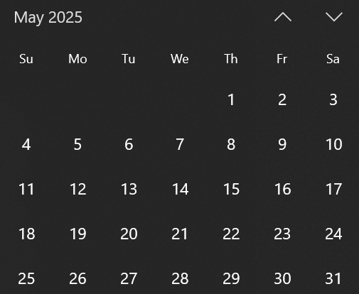

1. **Adjournment-** stop recording.