Good Standing Keeping Up with California's Nonprofit Reporting Requirements

Notes taken from:  
<https://www.youtube.com/watch?v=wcjBKbll47A>

## Federal Taxes

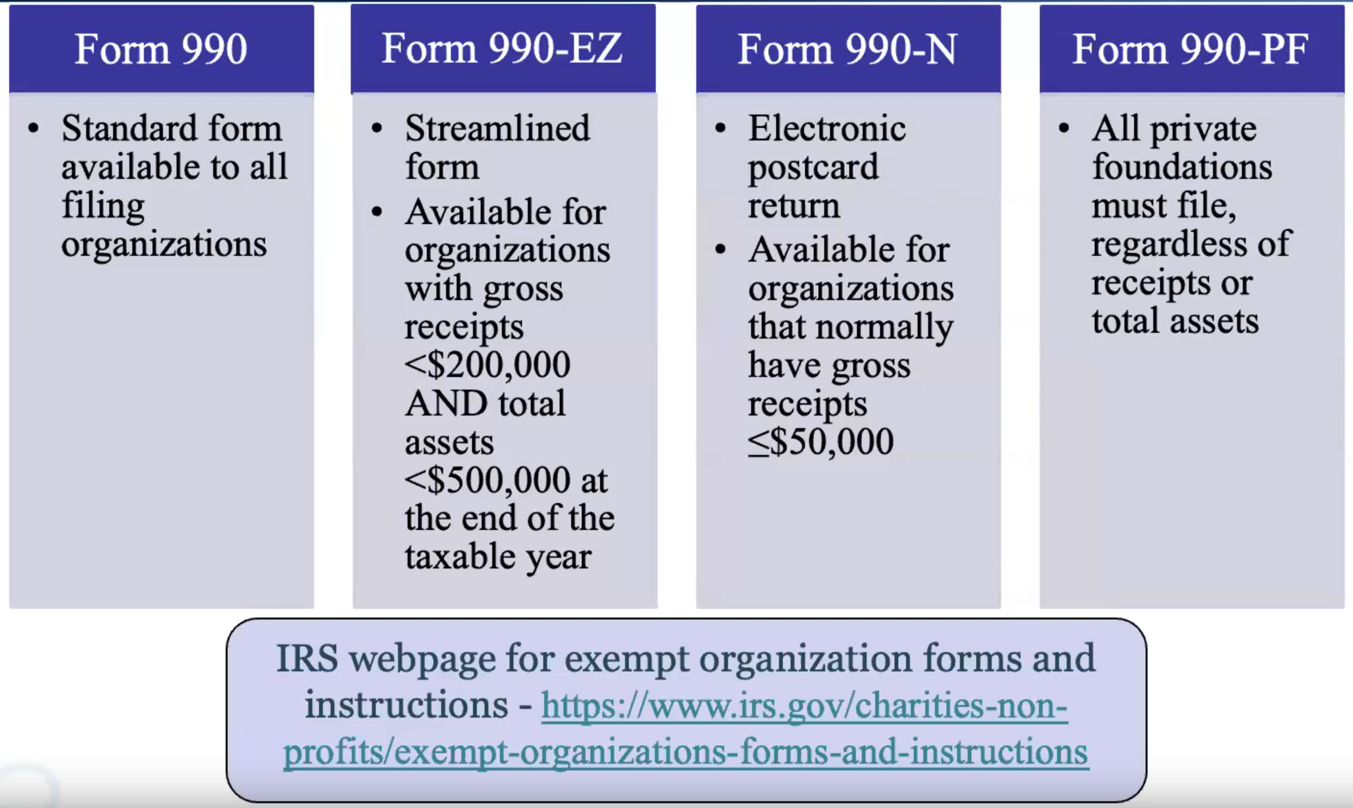

* For all donation of $5,000 or more also need to file a 990 Schedule B
  + This is $5000 in total contributions from a single person, including cash or asset donations.
  + When filing a schedule B include all donor information, this is kept private
* The base 990 needs to be made public and donor information should be kept anonymous. Thus there will be a public and private 990 form.
  + Be careful about personal information (personal address, social security ID, etc)

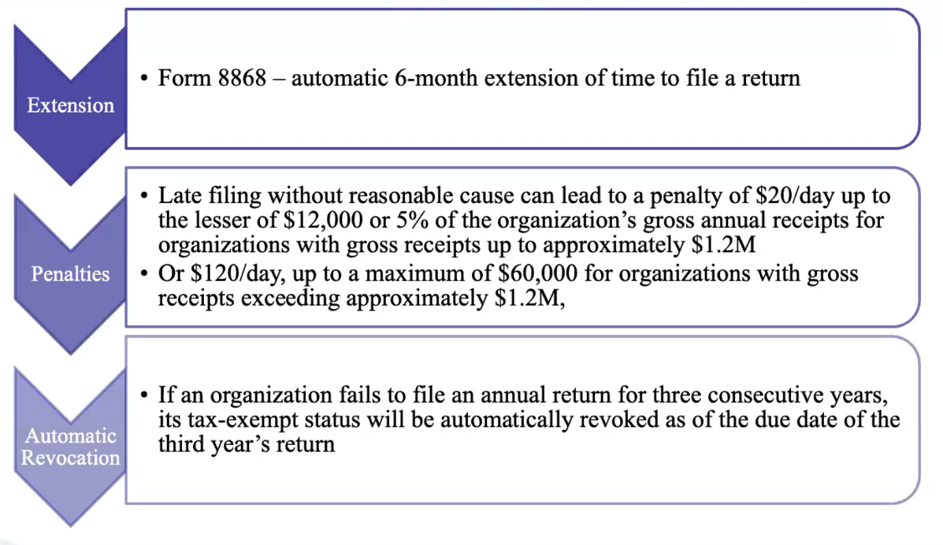

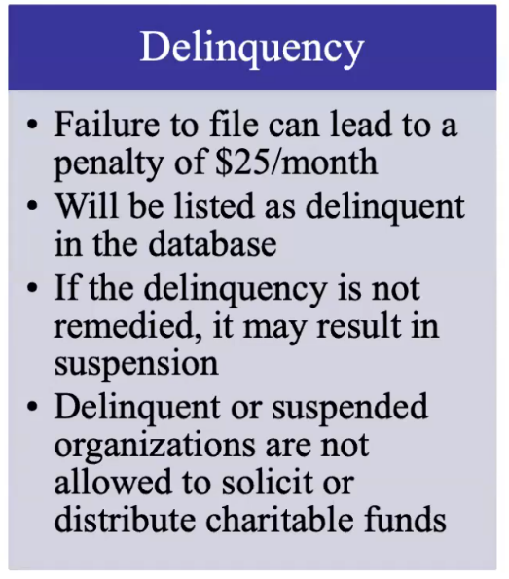

## California Taxes

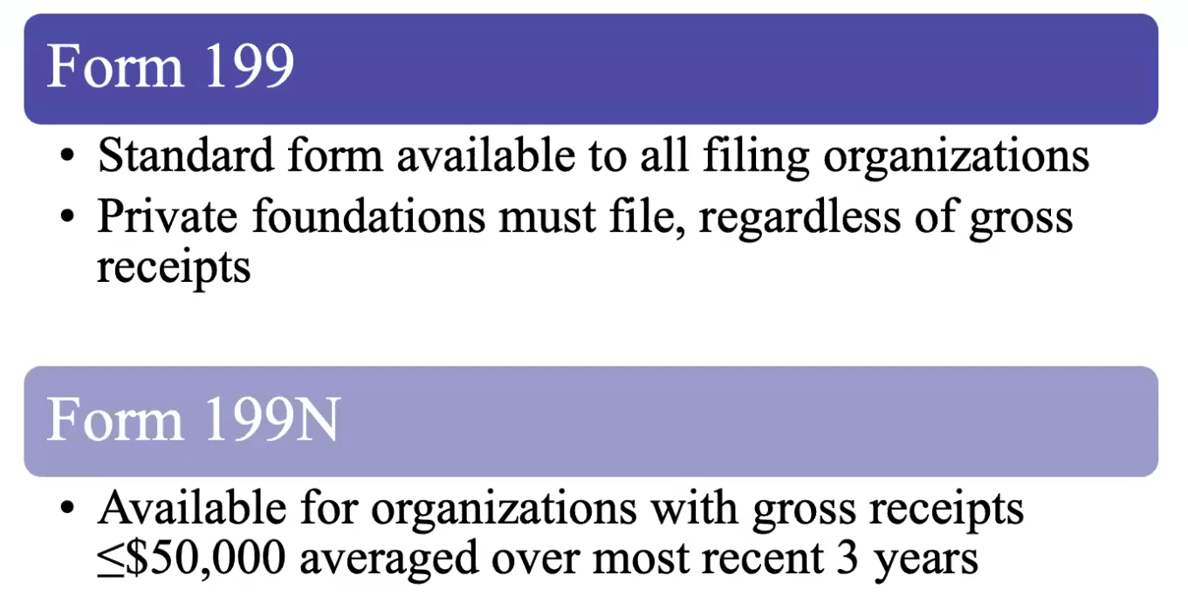

* FTB109 form for unrelated business income
* State taxes due at the same time as the federal taxes

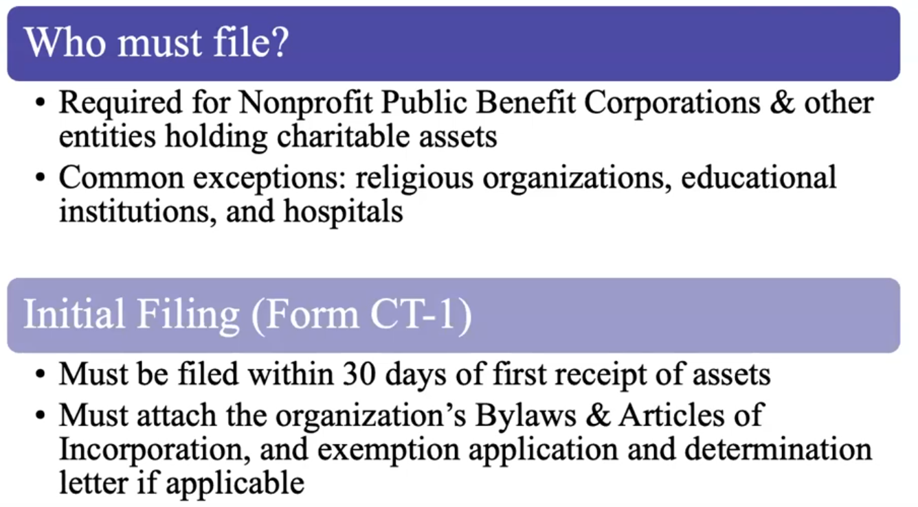

### State Ongoing Renewal Registration Requirements

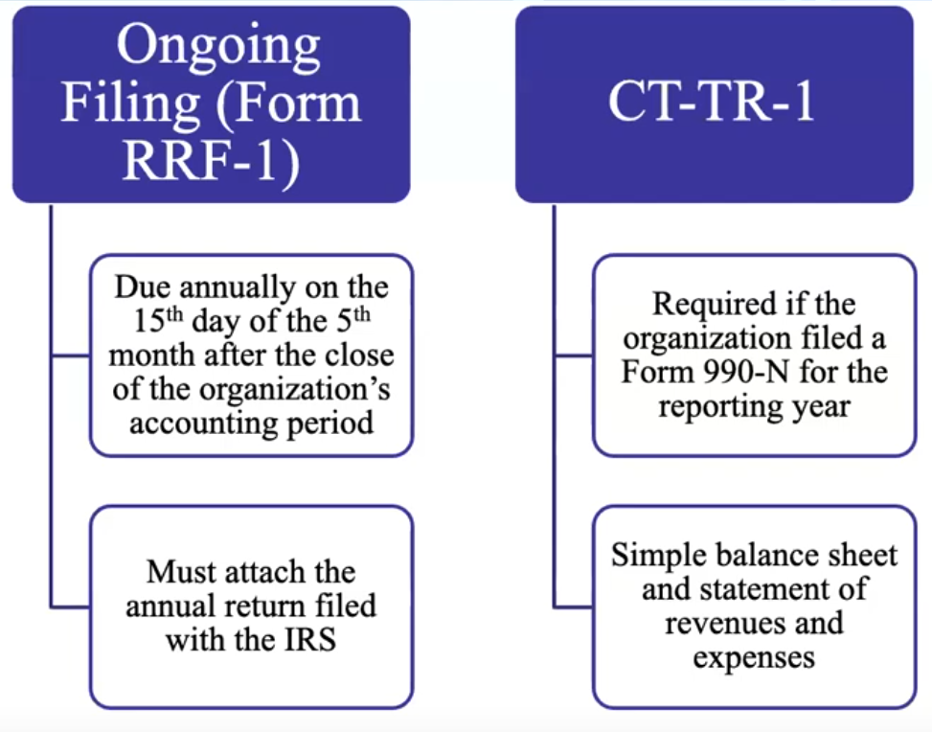

### Periodic refiling requirement for Statement of information.

Need to update the Statement of information every 2 years. $20 filing fee. (rate sheet on Form LLC-12)

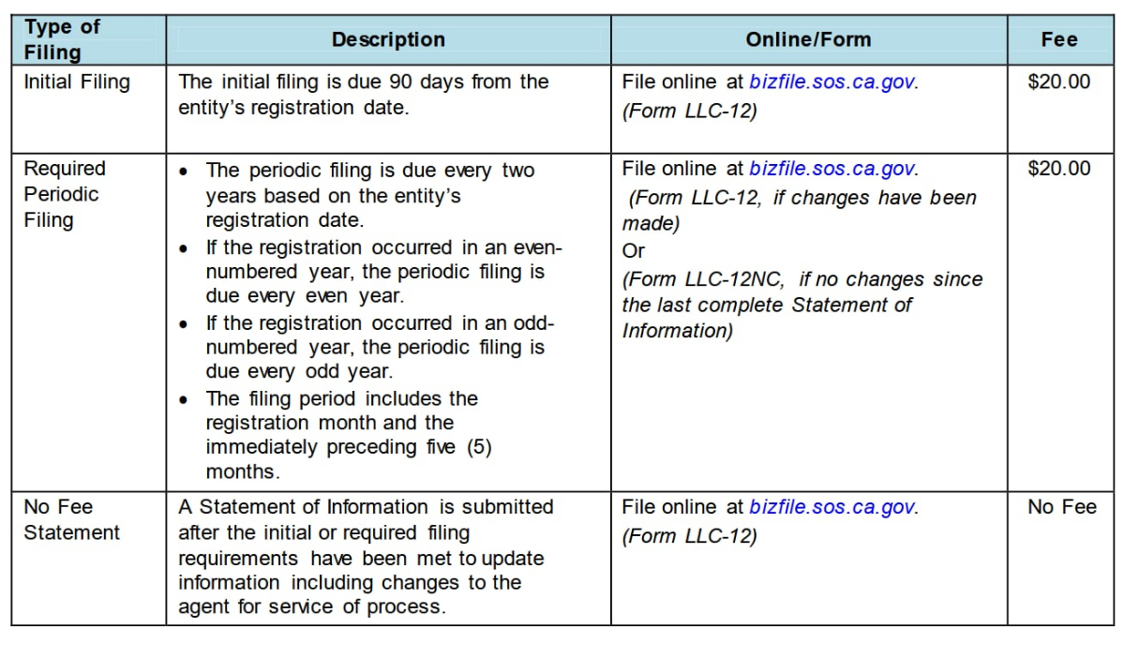Need to update the Statement of information every time an officer (see below) changes. This is free to do. Corpora lists Monarch and PM as CEO and CFO.

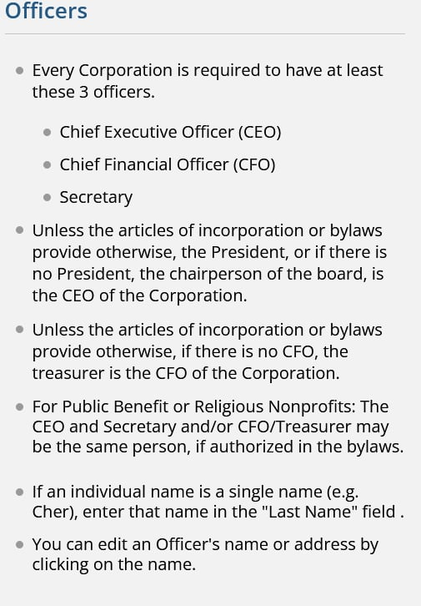

## How to check status and file documents online

