**Meeting for Westmarch BoD July 16, 2025, 7pm PST**

Join Zoom Meeting

**https://us06web.zoom.us/j/86724160744?pwd=vbMON8xcWioWbtqaW2OLAaumb4lTOY.1**

Meeting ID: 867 2416 0744

Passcode: 740847

1. **Meeting call to order**
2. **Attendance Call**
3. **Officer Members in attendance**: Ethan Copitch, Ginger Conrad, Leon Starks, Royce Griffiths, Karl Craig, Athena Velasco
4. **Guests in attendance:** Jack Kiernan

Start recording.

**Agenda**

1. **Reading of Minutes of Last meeting**
2. **Monarch Providing Credit for Attendance?** 
   * **YES**
3. **Reminders from Last meeting – Reminders (Ethan)**
   * **Director and officer insurance. – get to PM althing week of 16th**
     1. Will work with monarchy to get on an althing. **(Ethan)**
   * **How many years we want to average for budgeting purposes on events.**
     1. 3 years Will need to update the BOD handbook **(Ethan)**
   * **CEO/CFO change to corpora draft Althing Item**
     1. Or update Statement of information from Secretary of State (CA) every monarchy election. **(Ethan)**
   * **Contract updates Ethereal Hollow, Stoneheart, Anduril**
     1. Both lands returned paperwork. Brian has gotten Adobe to agree to 501c3 status. Will work on resending these to the BOD.
   * **California Tax Exempt status (Ethan)**
     1. It has been completed and set to the state. Pending determination.
4. **Fundraising idea from member (Royce)**
   * **Phantom fireworks as a 501c3 we could sell fireworks, would need to apply back in February.**
   * **Worth exploring for locations that allow fireworks.**
   * **Additional Information** [**https://drive.google.com/file/d/1tC21Du__DkkuB4iBZzwHBdRgSDZ6a5xf/view**](https://drive.google.com/file/d/1tC21Du__DkkuB4iBZzwHBdRgSDZ6a5xf/view)
   * **Liaison to lias with firework company, ask about minimum selling times.**
5. **Darkshore update – Athena**
   * **BOD needs to sign the event review form.**

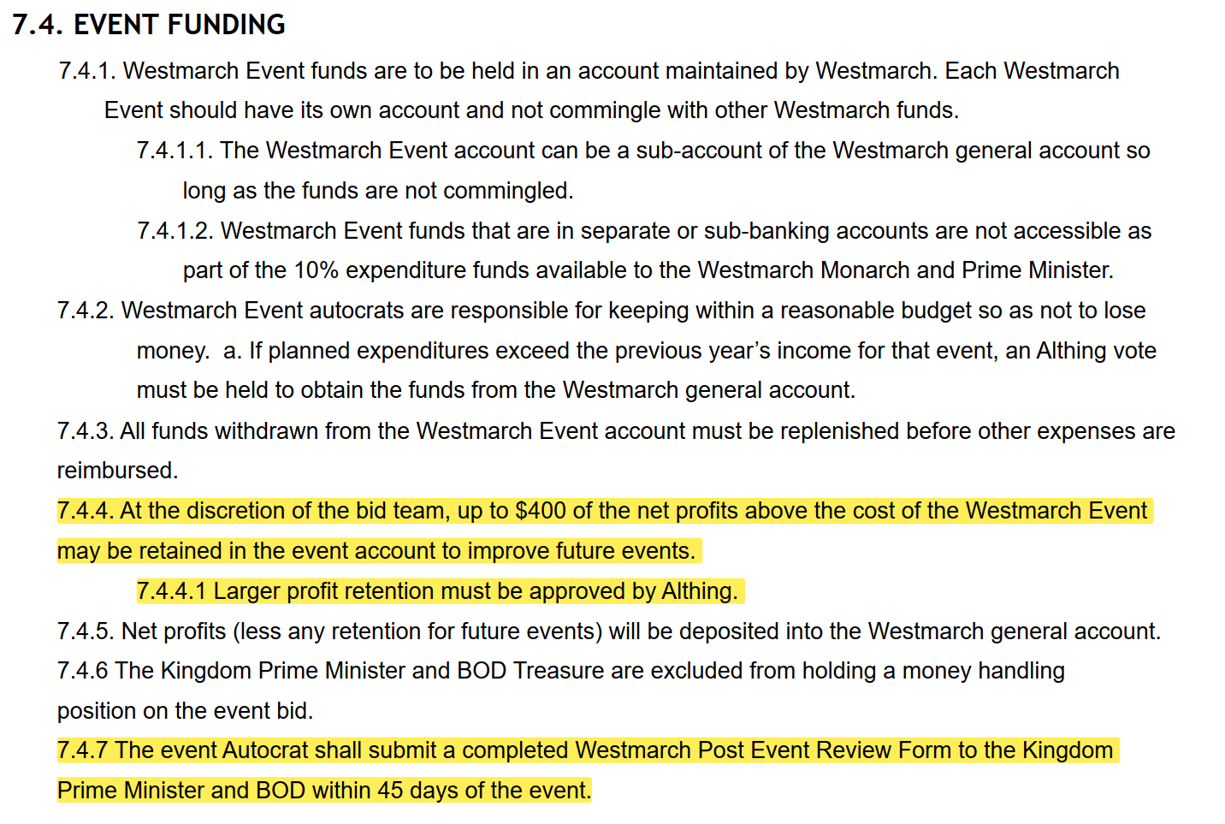

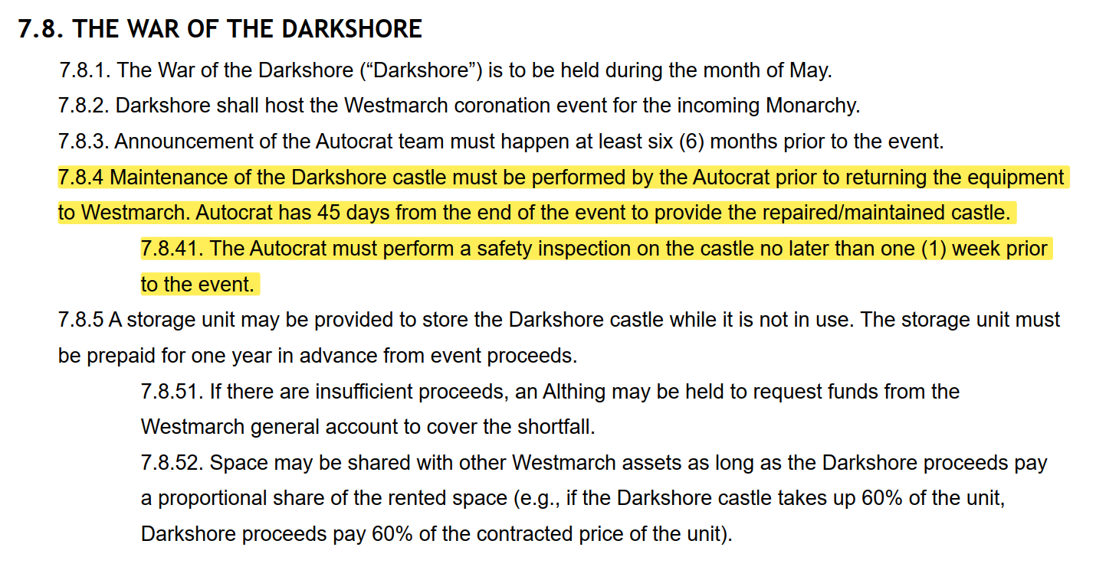

* + **Inspection. As the owner of the Westmarch property the regent shall ensure the castle is in good repair.**

1. **Missing BOD member and next steps**
   * **Board shall send the election information to the PM.**
   * **10.1.3.2. Candidates must announce their candidacy publicly and in writing to the Prime Minister at least one week prior to the election.**

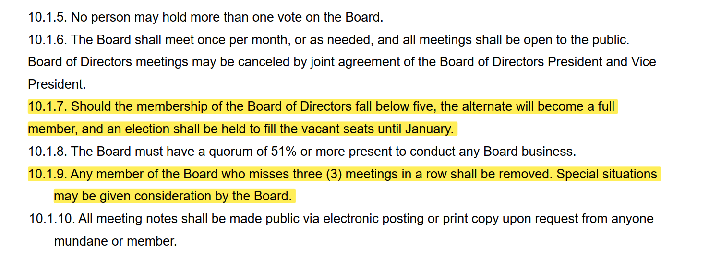

1. **Walk on items**
   * **Royce – Xeno of SG is working with Ex-Com to get high quality production value videos for Youtube. It would be good to get a lot of view of them to use the algorithm.**
   * **Declaration for the Kingdom PM is due July 19th.**
   * **Seller’s permit for the kingdom and how to get it.**
2. **SCHEDULE:**

* August 20th, at 6:30pm

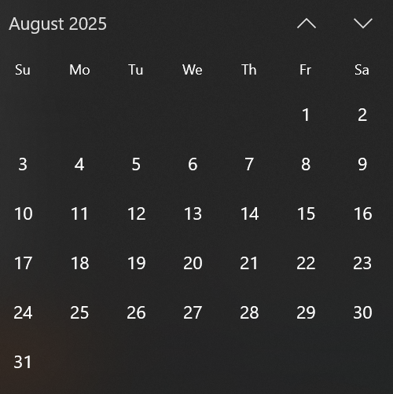

1. **Adjournment-** stop recording.