**Meeting for Westmarch BoD Sep 17, 2025 06:30 PM Pacific Time**

Join Zoom Meeting

https://us06web.zoom.us/j/86810222298?pwd=DlAVcldO6ZONKxajitH7nmFADrenTn.1

Meeting ID: 868 1022 2298

Passcode: 902590

1. **Meeting call to order 6:35**
2. **Attendance Call**

**Ethan Copitch (Sebastian), Christine Stender (Ailanthus), Athena Velasco (Athena), Karl Craig (Ilion), Ginger Conrad (Dash), Leon Starks (Cinderhild), Royce Griffiths (Theos)**

**Frankie DiMento (Dagger)**

1. **Officer Members in attendance**:
2. **Guests in attendance:**

Start recording.

**Agenda**

1. **Reading of Minutes of Last meeting**

**Approved as read**

1. **Monarch Providing Credit for Attendance?**

**yes**

1. **Reminders from Last meeting – Reminders (Ethan)**
   * **Update BOD handbook (Ethan)**
     1. Add - 3 years average for budgeting purposes on events - update the BOD handbook

Pushed to next month

* + **CEO/CFO change to corpora draft Althing Item (Ethan)**
    1. Or update Statement of information from Secretary of State (CA) every monarchy election.
    2. Pushed to next Althing.

Pushed to next month

* + **Contract updates Ethereal Hollow, Stoneheart, Anduril (Ethan)**
    1. Both lands returned paperwork.
    2. Brian has gotten Adobe/Docusign to agree to 501c3 status.
    3. We now have Doucsign, BOD can finally sign these.

COMPLETED!

* + **California Tax Exempt status (Ethan)**
    1. It has been completed and set to the state. Pending determination.

No change

* + **501c3 Business donation Pamphlet**
    - 1. Someone (Milan?) to make pamphlet to present to other business about donating to our 501c3.

Athena volunteered to help. Monarch asked Milan to continue working on it.

1. **FOG check in, does the BOD need to do anything?**

Do not need anything

1. **D&O and General insurance update (Ginger)**
   * Althing Passed. Liaison to liaise with insurance to get it ordered.
     1. KPM to pay! (from Westmarch general account) up to $2572

Because we waited so long it is $11 more. Set up, one-time fee is $300, which was unexpected, so may need to go the althing. $886 for first payment. $500,000 coverage. $2572 is one year of liability for every land, every meeting. $3.80 per participants, per year. 393 average unique sign-ins per month.

1. **Cleanup of old castle storage contract?**
   * Did we ever cancel the Azus contract for storing the castle? since it is now with the trailer. If now, how do we do this?

Does contract need to be cancelled? Ethan will write email confirming cancellation. Theos will send with Kingdom email.

1. **Correction of BOD bylaws.**
   * The BOD bylaws that were filed with the IRS as part of the 501c3 transition need some updating.
     1. The BOD can do this updating with sufficient votes.
     2. Need someone to go and make a list of items that need correction and propose them to the BOD at a future meeting.

Article 12 outlines how to amend bylaws. 2/3 vote BOD needed to make changes. Need at least two members to form a subcommittee to write up proposal. Ginger, Frankie, and Christine, Ethan to form committee.

1. **Seller’s permit for the kingdom and how to get it (Athena/Royce)**
   * Any update?
     1. Past update - Royce still working on NAICS code to use for a LARP.

Still looking

1. **Kingdom Audit Status. (Royce)**
   * Does it need anything from the BOD?

Has not started. Projected start date… “soon”

1. **Walk on items**
2. **Royce – per IRS: We have none of the triggers that we would need to hire an audit firm. (SOBOX)**
3. **Theos putting up post to advertise selling space on trailer. 3X3 space for 3 years - $10 Will need a contract to rent the space. Athena suggests a contest with paid voting as a fundraiser. Ginger brings up needing the stickers to be easily removable. Athena suggests magnets on the bumper. Christine suggests dating the stickers. Royce to propose a specific contract in the future.**

1. **SCHEDULE:**

* 10/16/25 @6:30 pm

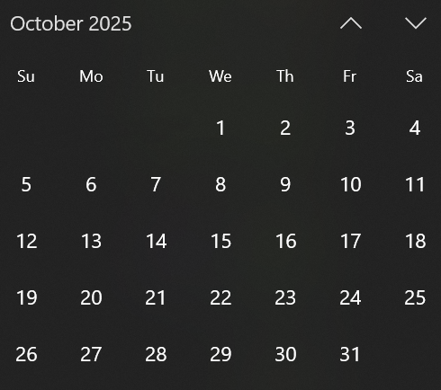

1. **Adjournment-** stop recording.

**7:26**