**Itinerary for Westmarch BoD April 2023**

**Call to Order and Roll Call** *Jose Chavez, secretary*

BoD Officer Members Andy ‘just, no’ Brown, Brian Ouellette, Jose Chavez, Paul Wilkins, Rose Brown, & Victoria Kathleen

Monarchy Members in attendance: Cynthia woody, James Anderson

**Reading of Minutes of Last meeting**

**Announcements / shout outs**

* Let’s work on encouraging people to update their AmtWiki Create an SoP to encourage people to do their amtwiki – Jay said they will do it.

**April Agenda**

**Monarchy Positions**

* Encourage others to get involved (brief discussion)

**Circle of Paragons**

* Thank you to dagger for bringing this to our attention
* Bylaws of Circle of Paragons fall under BoD jurisdiction
* We need to ensure the circle is forming and bylaws written
* 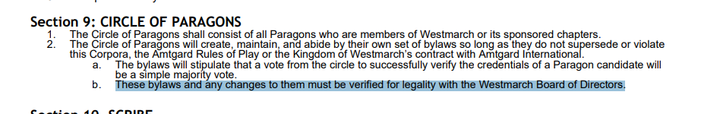
* *There is currently discussion for the bylaws. No completion as of yet.*

**Scribe Update**

* Article 4 section 8 sub clause 4 The Prime Minister may appoint and dismiss the Scribe at will.
* Introducing our new Scribe – Jay (they/them)

**Bank Account Access**

* Any updates from Cynthia or Andy?(Postpone to may)
* Payment to AI? ($500). (email AI to state we are mildly delayed and maybe get Justin to pay it OR have Cynthia pay it via paypal)
* What is our account balance? (paypal and wells) – Consolidation

**Taxes**

* Let’s get them submitted. Group effort. ( we need tax information from 2020 or 2021) – we need to submit 2022.

**Linktree**

* Shout out to Jose Chavez of Valley of the Fallen (awesome) James Anderson suggests Paul encourage all parks to create a linktree.

**Digital Waivers**

* Discussion on if we should have an allthing about it waivers are a contract and therefore Bod realms. / This will cost money however. / Do we leave it to just parks or all kingdom level? – make the proposal of ONE proposal instead of two. Funding and viability.
* If yes, then what? We need to find the level that works best for us. First month we would need to have ALL the waivers to re-waiver everyone. Keep all the waivers for always. We need to re-waiver every 3 years as per corpora. Possible corpora update??
* Rose Brown and Paul Wilkins connect and choose the best one to provide to WM monarchy?

**Trademark Westmarch logo**

* Discussion on if we should have an allthing about it – some members think it’s a good idea $150 every 5 years. – proactively protect ourselves. State level only not federal. Victoria brings up that we are protecting ourselves. Not trying to sue people for using the logo correctly. Any member of WM is welcome to use it within reason (possible corpora update suggested by rose)
* If yes, then what? Brian will look into it and put into a proposal in may

**Trailer Update**

* Storage is a very serious issue no real good option at the moment sadly.
* Corpora calls for storage? May - not required. It’s a bad idea to force someone to store stuff at their house. Trailer or not. Still forcing someone to store stuff. Storage unit is safer overall for numerous reasons.

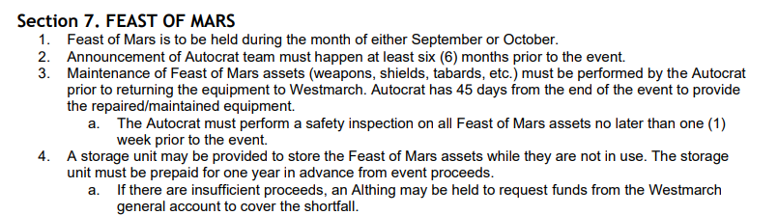

**Amtwiki**

**Brief follow up on AI**

* Email Brian wants to send.
* Details found from 2019 about fee (below)

[New "Licensing Fee" for Kingdoms](https://caamtgard.com/phpBB3/viewtopic.php?f=10&t=9021#p88062)

[Post](https://caamtgard.com/phpBB3/viewtopic.php?p=88062#p88062)by [ElSpeth Sharrisselva](https://caamtgard.com/phpBB3/memberlist.php?mode=viewprofile&u=37) » Wed Jul 24, 2019 10:42 pm

You have seen the first item of importance from the 2019 Interkingdom Circle of Monarchs at Clan. It’s time for the second one. This is something which will change how we promote Amtgard and certainly impact our futures.  
  
A proposal was made and accepted to impose a yearly $2,000.00 fee to each kingdom every year in perpetuity…payable to the Amtgard International Board of Directors. The first is due January 1, 2020. For lack of a better phrase, it is a “licensing fee” for the kingdoms to be part of Amtgard. I will fess up that I was the only monarch present who did not vote for it. If it were a one time cost, I have no doubts we could pull out the stops and meet the demand. I’m less certain about year after year. At any rate, it passed and we must live with the decision.  
  
It IS a lot of money and so alternatives to a flat fee were tossed around. None of them stuck and the flat fee is what was voted in. The first thing it is to pay for is the legal fees for the trademark battle. After that, where the money ends up is decided by the AIBoD.  
  
So what happens if we don’t pay? This first year there will be no penalties. After that—likely next Clan—what penalties applied will be decided. One strong “potential” is this: first year, stern warning; second year, the loss of a kingdom to give out higher awards; third year, the loss of a kingdom to grant knighthoods; fourth year…dissolution of the kingdom. This is serious business for us and so we must look to ways to meet this fee and not break ourselves in the process.

**Topics to be added to May**

**Do we have a bilingual flyer? – Rose**

**Should BoD have access to the WM drive?**

**Schedule for May Meeting**

**Tuesdays work well for me Wednesdays work as well. Rose may not attend in wingdings. Jay will only attend if it's wingdings. May 17th which is a Wednesday. 6pm?**

**Credits for this meeting? Yes as per Monarch.**

**Adjournment**