**Itinerary for Westmarch BoD October 2023**

**Call to Order and Roll Call Brian**

BoD Officer Members Andy Brown, Brian Ouellette, Paul Wilkins, Rose Brown, James Anderson

Guests & Monarchy Members in attendance: Ethan Copich Ben Smith Frankie Dimento DaviD Meirfrakenfeld Kris Sapolu, Stephanie edwards

**Reading of Minutes of Last meeting**

**Apprived**

**October Agenda**

**November 1st: Announcements for BoD 2024 Elections post announcement on all boards people report to WM PM (sorry james) Paul’s Squire / Rocheen (a lawyer) / Lyriel all want to potentially run. James refuses to run.**

**Wells fargo handoff Update: DONE! PM has full access. Interaction between PM and treasurer of BOD is imperative for successful process work. (if they can both be in a bank at the same time it helps a lot). Wet signatures probably required.**

**Mailing address for WM. Digital po box update: DONE!!! Oh my ZOGS. Send us that bulk mail!! Sears catalog? Yes please!! Biggest roadblock done was USPS form 1528 needed with correct addresses. Yearly fee is: estimated $125. What is a digital PO box? An email with extra steps. Legally we NEED a mailing address. We don’t ever have to actually check our mail. $99 a year to renew. Same price or cheaper than a PO box and don’t have to burden Kyle with using their home address. ~~DO we need to get approval for the PO box spending via allthing or just keep with Discretionary spending. (WE NEED TO UPDATE BUDGET)~~ We actually did pass an allthing saying it was approved. Rose will potentially get Milan proof of this**

**Ledger request from all parks for 2022-2023 as per monarchy update Most parks have submitted. 7 parks did not submit ledgers. Two of the 7 parks are now defunct.**

**Discussion: Non-Tithing parks – should they be allowed to vote on Kingdom issues? The parks that did NOT submit ledgers still must submit asap. No attacking. Just encouraging. Give them time. Can we legally not allow them to vote??? Probably not. Non ledger submitting is fine to vote (but potentially get demoted) non TITHING – Go to heck.**

**Do/Should we have a bilingual flier and waiver update (tabled forever?)**

**Request for Scribe – C’mone, you gotta know *someone* anyone??? TALON has requested to be SCRIBE OH MY ZOGS. (thank you Stephanie for asking, I heard you).**

**Feast of the Gods – Do we have the post event financials? What about Darkshore? Where are they housed for oversight and for future event stewards? It would be a great post event AUDIT for people to see what people paid for events so future crats can see what was paid. Rose suggested that she can potentially create this audit.**

**$359.00 insurance$3,490.00 park$95.98 service$554.99 food$644.00 other$11,034.85 gate (income)**

**Should V9 released soon for playtesting We have authorization from CoM and XcoM (we cannot require parks to playtest).**

**Coronation in November, Smooth Election? Can someone get me a list of the monarchy from all parks?? Next monarch can request an audit!**

**Forecast 2024.**

1. **501c3**
2. **Updated BoD verbiage**
3. **Updated Code of Conduct/Complaint**
4. **The corpora!**
5. **BoD Handbook?**
6. **BoD Oversight of Event Site Contract (schedule bod meeting around events)** Paul thinks Jodi did everything wrong, just like he did.
7. **Indemnity on Event Stewards**
8. **Liason vs event Stewards – who does what?**
9. **Mandating that all charges for all things are denied unless submitted 30 days in advance.**

**Topics to be added to November**

**Welcoming new Monarchy! With Violence?**

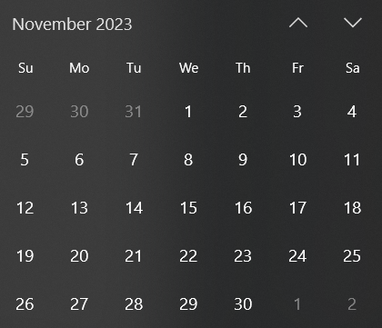

**Schedule for November Meeting**

*11/29/23Wednesday 6pm?*

**Adjournment**