**Itinerary for Westmarch BoD November 2023**

**Call to Order and Roll Call**

BoD Officer Members Andy Brown, Brian Ouellette, Paul Wilkins, Scorch Garcia, Tirzah Brown, James Anderson,

Guests & Monarchy Members in attendance: Ethan copich Benjamin smith Frankie Dimento, Chris Sapolu

**Reading of Minutes of Last meeting**

**Approved!**

**November Agenda**

**Welcoming new Monarchy! With Violence? “glad to be here”**

**…..so….. credits???? (stares at monarch) Tirzah asked the question**

**Audit update – Tirzah – would be a good idea to break down the ledger more. Milan suggested the Westmarch payment request form – James thinks our card servicing (wix) service is awful. (we need to replace?) – We are not properly tracking incoming fees associated with and for events. We have issues tracking ticketing sales of events. Wix breakdown of fees was fine but when the data transferred it corrupted the data when going through a 3rd party partner. We shouldn’t rely on third party data for our ledger. BoD does not have the authority to tell autocrats what to do or not to do in regards to how to collect and spend funds – We need to standardize payments. BoD has an obligation to comply with the duties of due care.**

**WM is liable for WM events. The autocrat is placed in a position in power at the bequest of WM.**

**-standardizing payments for events**

**- proper ledger methodologies**

**- better record keeping**

**-4th account for a general savings set aside account retained as per Monarch**

**Jorge Wahner made a 5k profit at FoG and deserves to be awarded for that.**

**- PODS for storage shed? Let’s get pricing. (volunteer for POD pricing ANDY)**

**- Why no Event Audit packets (Victoria) Put together an Audit packet for ALL events Before and After – mandated for the Bid Process (make a bid packet) (pre-paid credit card for bid)**

**- should we keep all funds in savings vs checking? (for interest) – Let’s make a decision on that.**

**Do/Should we have a bilingual flier and waiver update Talon worked on it. Milan going to look up cost for translation of waiver**

**BoD Nominations**

**Review of all corporas Ethan did a REALLY BEEG THING**

**WM safety statement update committee fashion update -**

**Digital PO box update (allthing for voting?) Lets test it and send something mail. – payment is yearly in February.**

**Andrew BrownKingdom of Westmarch#11422180 Vista Way Unit BOceanside, CA 92054**

**This is the mailing address for the digital PO box.**

**Ledger request from all parks for 2022-2023 as per monarchy update – re-request to ensure everyone has a ledger? – old monarch gone – new monarch – do we continue to request that each park has a ledger? Monarch says……. If they want to exist without a ledger then great but no votes. IF yes submitting votes then we need ledger.**

**IF no ledger then technically parks shouldn’t have any monarchy and cannot hand out local awards.**

**Should we seek feedback from WM as a whole if we want to dabble in v9? Not in the BoD realm for us to choose or decide.**

**Forecast 2024.**

**501c3 – should we seek feedback from WM if we want to dabble in 501c3? – It never hurts to get feedback – make an allthing for feelers? Even non voting members? Local PM feedback –**

**Invest in Google Suite? Andy will look into cost for a 501c3 and a c7**

**Topics to be added to December**

***A toast!!***

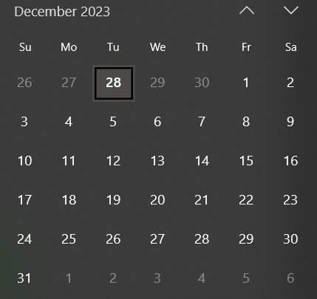

**Schedule for December Meeting**

*12/20/23 6pm?*

**Adjournment**