**Itinerary for Westmarch BoD January 2024**

**Call to Order and Roll Call**

BoD Officer Members brian Ouellette ethan copich ben smith Athena velasco james anderson scorch Garcia Kris Sapolu Andy Brown

Guests & Monarchy Members in attendance: We all love DUKE FRANKLIN DeSLAYer Esquire

**Reading of Minutes of Last meeting**

***Read and approved***

**January Agenda**

**POSITIONS**

**Pres: (Milan)**

**Vice: Ethan Copich**

**Secretary: Kris Sapoluuuu (from the top rope)**

**Treasurer: Andy Brown**

**Liaison: Ben Smith with the Talons**

**Scribe: ATHENA**

**Alternate: Athena**

**Monarch: Scorch**

**PM: James**

**Peanut Gallery: Dagger**

***Try to activate skyfire bay on the ORK to get Hawaii rolling* (update: several kingdoms have noted ork issues – working issue – to be updated) – WHO is the leadership of skyfire bay (SCORCH DELEGATES TO TALON)**

**STORAGE (update from James – Baccus is moving out of state and is storing Westmarch stuff at the house – We need to get the stuff AND move it *somewhere).* We have a contract with azus (david zucker). There is no contract with Baccus.**

**WE NEED verification of the contracts for storage. (matthew lister) David Zucker as well – Matthew Listers wife need her contact info if she stays in California and stores stuff (Megan Inks)**

**The income we earn from events may quantify the cost of a storage unit a year – How much storage space do we actually need? (10 by 5 by 5 minimum)**

**Do we have a volunteer to look up costs for a storage unit *SOMEWHERE in California (Ethan is gonna do it) (ben will QC)***

**OUT – There is an event in Westmarch that is not a kingdom event but within WM. OUT needs REEVES – security – NPC’s. FIRE RULES: no wood burning but gas is ok.**

**~~- PODS for storage shed? Let’s get pricing. Pricing for pods update: They’re weird. Everything was automated. Not Keurig pods. The big ones. $385 charge for deliver and $380 for pod monthly storage. HOLY <redacted>. MORE discussion of buying a trailer. Also discussed Uhaul version of pods. Would have to be an allthing. We store stuff at multiple houses. We need to store totes AND a castle.~~**

**Digital PO box update**

**Andrew BrownKingdom of Westmarch#11422180 Vista Way Unit BOceanside, CA 92054**

**This is the mailing address for the digital PO box.**

**WM BUDGET UPDATED FOR FEB (Milan)**

**Athena is locked out of ALL discord ( will wait for updates on this)**

**ADD NEW BOD MEMBERS TO Discord (Milan will make sure it will get done)**

**UPDATE ROLES for WM discord? (not a BOD issue)**

**WM OFFICIAL ANIMAL “Bear-Bear”**

WM Official SONG Shpadoinkle Day

**OFFICIAL flower “California RED ROSE” or the “special mushroom”**

**Official movie MULAN**

**ITEM: financial obligation in January – pay $500 to AI. This is a general mandatory account that should be added to the corpora or annual budget for a yearly allthing approval (NEW CORPORA section – policies of the treasury) Next allthing – have the WM budget on it.**

**Forecast 2024.**

**501c3 – should we seek feedback from WM if we want to dabble in 501c3? – It never hurts to get feedback – make an allthing for feelers? Even non voting members? Local PM feedback – This is a Monarchy and a BOD thing – potentially use NOLO or something similar to legally do it right. Potentially add to budget**

**Discussion: dues – value – importance – financial impact (not crucial).**

**WM PM will be fleeing the country.**

**February Schedule**

**What should we add to the yearly budget?**

**501c3 update**

**Scrolls – Discussion – how many AND how much are we spending?**

**Dues paid and tithing update for April**

**Order of the Invoice – added to corpora as a ladder award**

**BoD members added to discord?**

**Leadership of Discord updated?**

**Contract verification for storage?**

**February Schedule**

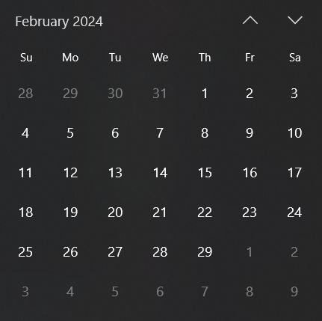

**February 9th at 6pm**

**Adjournment**