**Itinerary for Westmarch BoD March 2024**

**Call to Order and Roll Call**

BoD Officer Members: Scorch / Brian / Andrew / Ethan / James / Talon / Athena

Guests & Monarchy Members in attendance: Dash

**Reading of Minutes of Last meeting**

***Approved***

**March Agenda**

**Can we officially pull the aureus saltus contract? They do not meet. But records are there. They have shut down but not returned anything. They are not listed on the ORK. Reach out to Saint Ka’a to see if there was any communication. There was a motion to remove the contract. Discussion occurs. Before we dissolve anything then we need to get assets from them. – Dash says they may know members of the park.** [**https://ork.amtgard.com/orkui/index.php?Route=Park/index/598**](https://ork.amtgard.com/orkui/index.php?Route=Park/index/598) **(who will reach out to them? Milan will reach out to them).**

**AI BoD – overpayment discussion (and payment) – Not a bod issue. We have the agreement of new $500. We paid for 2024. Andy will potentially find the agreement for $500 contract**

**SharkDoor Insurance – waiting for a payment request form. We need to see the sharkdoor bid. We should not mandate people to pay up front and then get reimbursed. Insurance – Under the autocrats name or WM name? Group agreement that it should be under WM and not put it on the autocrat. BID needed to be updated because Milan had the wrong days. Separate topic: Insurance under WM name / then how we fund should be with OUR funds not Autocrat funds. How do I pay for things as an autocrat? The BID cannot be an invoice. MILAN will eventually write a SOP for Bids. PAYPAL can issue cards. WM has Zelle and Paypal. We do NOT have a Venmo.**

**PAYPAL DEBIT CARD RESEARCH – Seems to be REALLY easy. This may be the WAY for Autocrats moving forward. Cost? (DASH is doing research for us) TABLED until April.**

**Event Waiver – what should it include DO we even need a waiver? Vote for NON members of WM and NON members of Amtgard. SO – how do we verify they have a waiver on file. We should review our existing paper and online waiver. CAN we have Smartwaiver Expire after 3 years?**

**DO all BoD members and members of monarchy have access to Discord? – YAY we all have discord.**

**IT committee update Scorch is kingdom Daddy.**

IT committee should gain admin abilities on the Discord.

IT committee should set this up correctly.

Azus is appointing people to the IT committee with approval Monarch



**DEI updated statement for WM conversation. Athena is doing it**

Table until Brian is available.



(This is James)

**Voting eligible players in WM – in corpora – not in the RoP**

**Sebastion did research on Storage VS Trailer MILAN GET PRICING ON TRAILER.**

**DASH MAY BE ABLE TO HELP.**



**April Schedule**

**APRIL 26th – 6pm.**

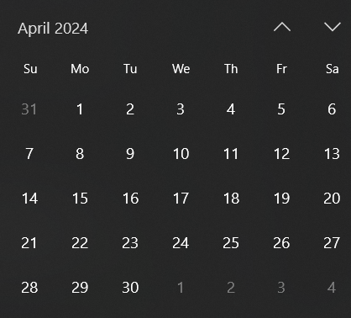

**April date for meeting**

**BID SITE Has potentially outgrown us**

**As a 501c3 we can do the thing**

**Looking for a new site. OR – Upgrade the King City Site.**

**Cost of a site is prohibitive.**

**Adjournment**