**Itinerary for Westmarch BoD April 2024**

**Call to Order and Roll Call**

BoD Officer Members: milan ouellette ethan copitch kris Andrew brown ben smith James Anderson Athena velasco scorch Garcia Dash!

Guests & Monarchy Members in attendance: Frankie

**Reading of Minutes of Last meeting**

***March minutes……approved***

**April Agenda**

Congratulations to our new (pending) Monarch! (yay)

Comments about the Regional Events from the Monarch and BoD responsibility (contracts) Kingdom level events – 4 events. IF crat wants to do a contract then the BOD needs to review insurance or other contracts. No need to review payments. Dash bribes the monarch.

May Vote: Alternate to full member (or something to that nature) – table as we have no answer. – We would like to find a pathway to get the alternate full voting. Let’s try to get November end reign the END of November.

Does the BoD need a layout or a template of what to expect from events before approving? – BID form exists and that should be fine – We should make a WIKI page. Jodi says she may be able to help with this.

Aureus saltus Update? What the Salties would like to do is run a reunion park day, for a one last huzzah, hold a final vote and then turn the park into a Household. Aureus Saltus had a lot of members back in the day, and as we all moved to different places, it lost its footing. But we’re all very much Salties in spirit still, and we’d like to celebrate that if the BoD will allow us to. (**update requested as of 4/22)**

We don’t have a specific timeline yet - I apologize I’m actually starting another trial this week, so my brain has been a bit elsewhere. My hope is to schedule a date for 2025 January/February, so we won’t overlap with any events or Holidays, and allows some of our seasonal players the chance to be available, but I haven’t confirmed yet with the other interested Salties. Would that timeframe be okay if it works with our folks? Potentially $400 in their coffers – we asked) – REPORT IN NEXT MEETING – Add to Running Ledger. Discretionary spending.

SharkDoor update: Any news about payments or contracts we need to discuss? – site payment check was mailed out! Let’s make sure we send it with tracking in the future.

Caamtgard update on payments and the like – how is it working? Please keep using paypal as per IT team -

Smartwaiver discussion: Current Corpora requires some sort of ID. (2.1.1.1. A valid, legal form of ID is required to be presented to the land representative accepting the waiver at the time of signing (see Article XIII for the waiver and instructions). ) What will new corpora say? Let’s make a new and easier OVERALL waiver. Also let’s standardize gate so that we have less need for constantly making waivers necessary. Ben reached out to all of the monarchy for Smartwaiver. SOME lands responded 9 of 19. So 10 lands still need to gain access.

~~Tournament North/South issues. Resolved? BoD issue?~~

DEI updated statement for WM conversation. Any update on this progress? **(Athena did a thing!) – Unanimously accepted.**

Liason: start looking for a new Darkshore location? Ben is already looking! Athena has offered to help. Jodi talked about a SLO site that may be called French Camp. Buena vista aquatic area in Taft is also an option. Fantasy Faire may be an event site we can use!?!?!?! Outside of SLO – Dash says Laguna lake in SLO –

Location hunting committee – Athena is volunteering to be part of Ethan’s group.

501c3 update: Milan working on proposal. Not done. Slacking. Sebastion has made some good suggestions.

We can secure the site on the Monterrey park a year in advance and pay via card with a 2% fee.

MAY Schedule

May 15th at 6pm

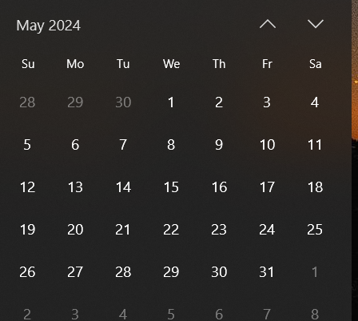

Add to May Meeting – Bear bear details about 501c3

Adjournment