**Itinerary for Westmarch BoD May 2024 March 15th 2024, 6pm PST**

1. **Call to Order - Ethan**
2. **Roll Call - Kris**

**BoD Officer Members in attendance:**

**Guests in attendance:**

1. **Reading of Minutes of Last meeting held in April (to be found on the WM Discord Bod channel): Approved? Y / N**
2. **MAY Agenda**
3. **Update from Ethan about his Duality on the Bod:**
4. **501c3 update from Milan:** Brian/Milan will probably not be here for this so here are the updates: ALMOST DONE. Thank you to Ethan and Ben for their invaluable help. Had a good hour long conversation with the IRS. We are now completing form 1023. We cannot complete form 1023EZ (the cheaper one) because we’re a c7, so the cost is $600 instead of $250. Milan has discussed with the monarchy about excess costs. Form is 99% done. Bylaws and articles of incorporation good to go. Need to be signed by secretary (Brian has discussed with Kris) and notarized (Brian is taking care of). Goal to submit final bid before end of month. Waiting on Financial information. Need Leger info from the Past 5 years for the 1023 application. Otherwise we’re good to go.
5. **Kingdom level events for Ethan’s Reign:** Any submissions yet? Call for submissions.
6. **Darkshore:** Has the BOD received the final results of the paperwork for auditing? Did Darkshore turn a profit? Please reach out to Alura and ohlanna for details on final results. Where are we storing final data for events moving forward.
7. **SoP or FAQ on what the WM BoD** wants moving forward in regards to info before and after kingdom level events. Any volunteers on creating this document? (if nobody, Milan is interested).
8. **Final discussion about Aureus Saltus**. Last conversation was with Victoria. They have $253.47 - will WM just ‘gift’ the funds to them and call it a day? Last update from Victoria below.

**The Ledger from Ka’a that she sent to the BoD puts us at $253.47 is my understanding of where we are. She was the last PM and has kept the lockbox with the AuSa coffers stored. She indicated that she’d give me a final update in June, but I imagine that the ledger she provided is accurate.**

1. **Bear Bear (Kris) requests to speak about 501c3 research**
2. **IT Team** – What support can the BoD give the IT Team to help them (them = just azus right now) continue the needed updates to the Website.
3. **FoG and Location conversation – location/paying in advance to reserve / Volunteer party??.** We can secure the site on the Monterrey park a year in advance and pay via card with a 2% fee. Is there a conversation still ongoing about the Renaissance festival and FoG potentially being there instead of King City or no? – Also, if King City, can someone please update the 2024 WM BoD about the volunteer option for site fees. Please find the forms attached in the Wm BoD channel.

The Monterey County Parks Ordinance Section 14.12.30 MCC states who may be exempt from fees – see below.  14.12.030 – Fees, subsection G The following persons are exempt from the fee requirements of this chapter for any Pass or Permit: officers, employees, agents, and contractors (and employees of the latter) of any governmental entity, while engaged in the performance of their official duties; concessionaires of the County and their agents, employees, suppliers, and contractors, while on the business of the concessionaire; employees of public utilities while in the performance of their duties; such other Persons as may be designated by the County Board of Supervisors. Those who do not fall under this code may have a Fee Waiver Request considered; however, the group must give back a benefit (volunteer service) to the park (San Lorenzo Park) in lieu of paying the reservation fees.  Please provide justification (use a second page if necessary) on what benefit your group will give back to the park.  I attached the Fee Waiver Request Form and Facility Use Application for completion. Some ideas might be a clean-up day or a special project at the park, trail maintenance, removing invasive plant species, etc. All projects would be approved and scheduled with the Admin Operations Manager and must be completed within six months of your event if your fee waiver is approved. Please let me know if you have any questions.

1. **Location hunting committee** **for future events**– Athena volunteering to work on this. Any suggestions or updates?
2. **SCHEDULE:** June Schedule for BoD meeting. Milan is not free 6/27

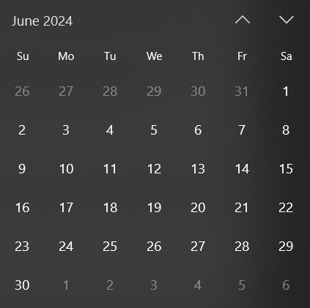

12: **Adjournment-** stop recording and send to Milan for uploading to WM Youtube.