**Itinerary for Westmarch BoD Meeting June 26th 2024, 6pm PST**

1. **Call to Order – Brian or Ethan – Ben**
2. **Roll Call - Kris**

**BoD Officer Members in attendance: Ethan, Brian O Ben Smith, James Anderson Kris andy brown athena**

**Guests in attendance: Alex S, Royce griffith, Ginger Conrad, Frankie Dimento, Christine Stender. Monica Cross. Alan Wong**

1. **Reading of Minutes of Last meeting held in May (to be found on the WM Discord Bod channel): Approved? Y / N – MOVE all notes to wikipage until ca is up and running ben can transfer**
2. **June Agenda**
3. Potential Darkshore updates: Have we seen final information for DS for auditing purposes. – june 7th documentation was sent over for final DS details – Monica is screensharing her Darkshore. Email monica if you want access to darkshore data. Alura was given $800 and sent money back – Fhirrin was given money and gave money back. So finances are all square. Possible discrepancy of 30 dollars between the two individuals. – Corpora question – is the PM storing information of post event updates? We need to prioritize that moving forward. CAN we HOST this excel sheet in a google drive moving forward for ALL events – We need to be using this excel sheet going forward for ALL events.
4. **FoG:** UPDATES on FOG licensing. Alan joined us and got in contact with a rep from County of Monterrey (Sabrina Guzman). We need an alcohol license. This is new for 2024 and onward. Permit is $40.00. We need Alcohol insurance to get the permit. We are having issues with online registration because we would have to pay for additional days if we register online. Clause in permitting that we MAY need security. Uncertain if this is true or not. Days are held but not confirmed as of yet. Guard situation concerns – Cost / liability / can we get members to do it? County of Monterrey may require more than just one guard. Possibility of a dry site for FOG - July or August Bod meeting Alan will come back. Possible august althing alan may want to add things to it – August 20th. – possible future site searches to new spots. Dry sites have MORE options. Like boy scout sites.
5. **Update about TRAILER from PM / Treasurer / Pres.** Royce checked out the trailer. Ginger is picking up. Zelle issues. Payment issues but wells fargo helped out. Can we look into changing limits? Keep the limits instead of expanding limits. Site rental fees is the big and only real issue.

* **Trailer Fundraising. Naming rights – novelty licensing – logos – stickers – Stained glass – We need a contract for Dash – use the same template as azus. $12.00 a year. BEN will draft the contract. Same contract as with david zucker with necessary adjustments submitted to BOD for approval – We may no longer need a contract with David.**

1. **501c3 update from Milan:** We completed form 1023. 6 month waiting period for processing
2. **Bear Bear (Kris) requests to speak about 501c3 research (postponed to July)**

* Theos (Royce) Requests to speak about 501c3 - **Happy Birthday to Theos Corbie – He wanted to talk to the finance portion of our non profit. We have to follow generally accepted accounting practices. We need an income statement and a balance sheet. We have to start stepping up our finance tracking as of NOW. Data tracking is really important for us moving forward. We can still use 990n postcard.**

1. Financial Update (after Trailer purchase): Ledger is up to date. Can we do a CD moving forward? Should we? Table for next month?
2. **SoP or FAQ on what the WM BoD** This is milan reminding himself he needs to do this
3. Termination of Contract for Nymyrs Sanctum. (VOTE) Y / N – last credit was june of 2022. Nobody wants to resurrect it – they started a freehold instead. All funds were transferred to James. $fund amount was $150. Vote passes with some squabbling. 6-0 (with one not present) Athena made a funny joke and we all laughed.
4. Vote for vice president: Andy nominates Athena:

President: Brian Yes

Monarch: ethan yes  
I hate andy: yes

Prime minister: yes

Liason (large): Ben

Vice president: EMPTY

Secretary: not here

AT LARGE member: yes

1. **Location hunting committee** **for future events**– Athena volunteering to work on this. Any suggestions or updates? Ginger and Athena and ethan will be working on making a group chat.
2. **Impromptu BoD Rap Battle**: Who’s got beef? Sling that slang! ATHENA WINS – someone nominate her.
3. **SCHEDULE:** July Schedule for BoD meeting.

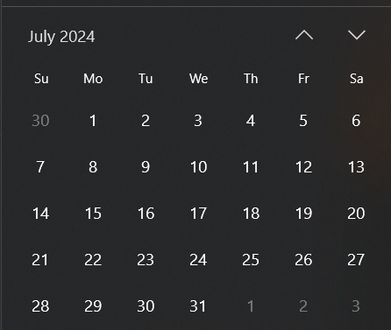

July 24th at 630pm PST.

12: **Adjournment-** stop recording.